Fixes 9.15.2017

1. Please set the default Smooth at 20% and remove the physical slider from the interface.
2. Please replace the bottom chooser (Male, Female, Kid) with more specific new icons (Man, Woman, Boy, Girl).

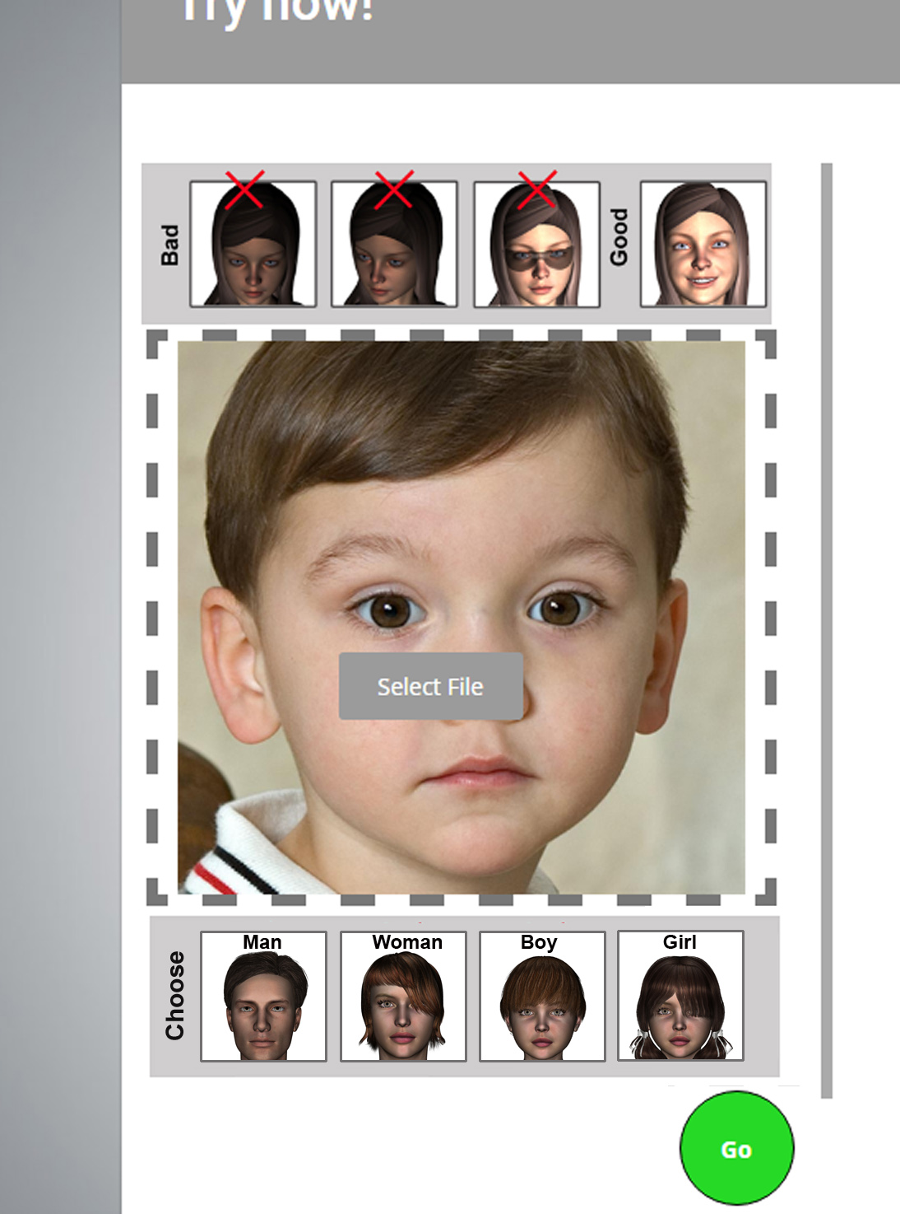

The reason for this change is that we can now open with default hairs specific to boy or girl as shown below. Default hair color also changes as shown.

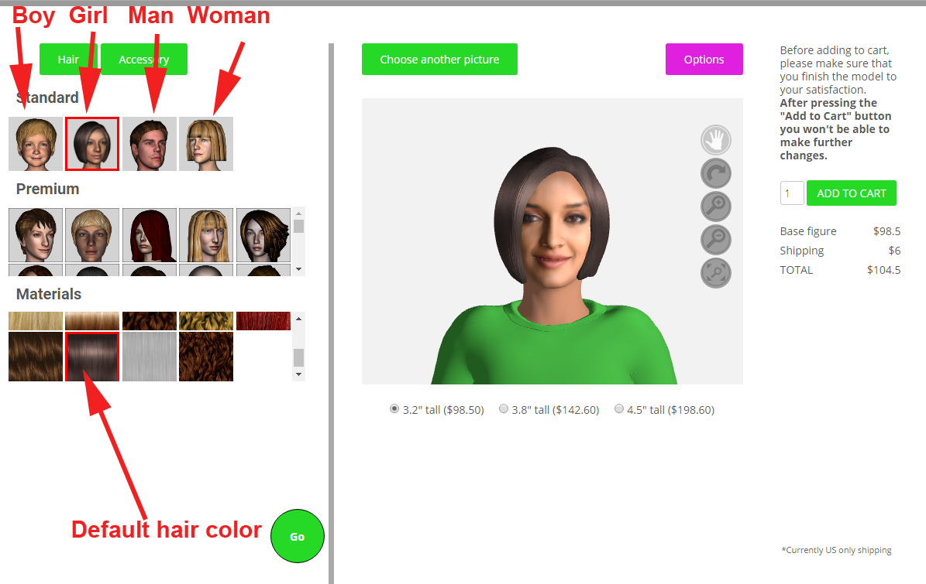

1. We have a bug with the child’s neck. Not sure what causes it.

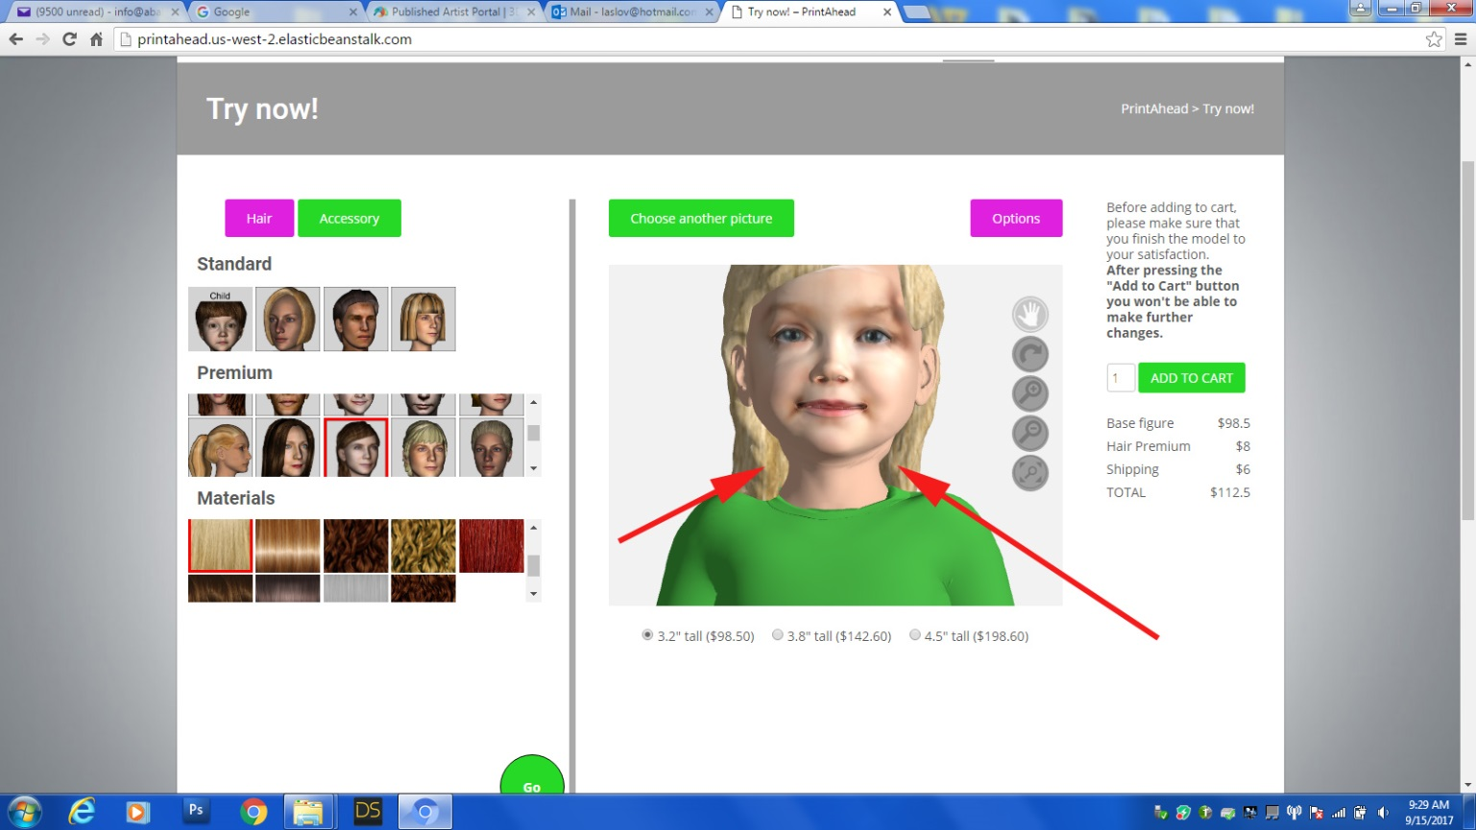

1. On all browsers (Safari, Firefox, etc) on the Macintosh the slider-bars left of the of the library items don’t show up (not visible). Please check